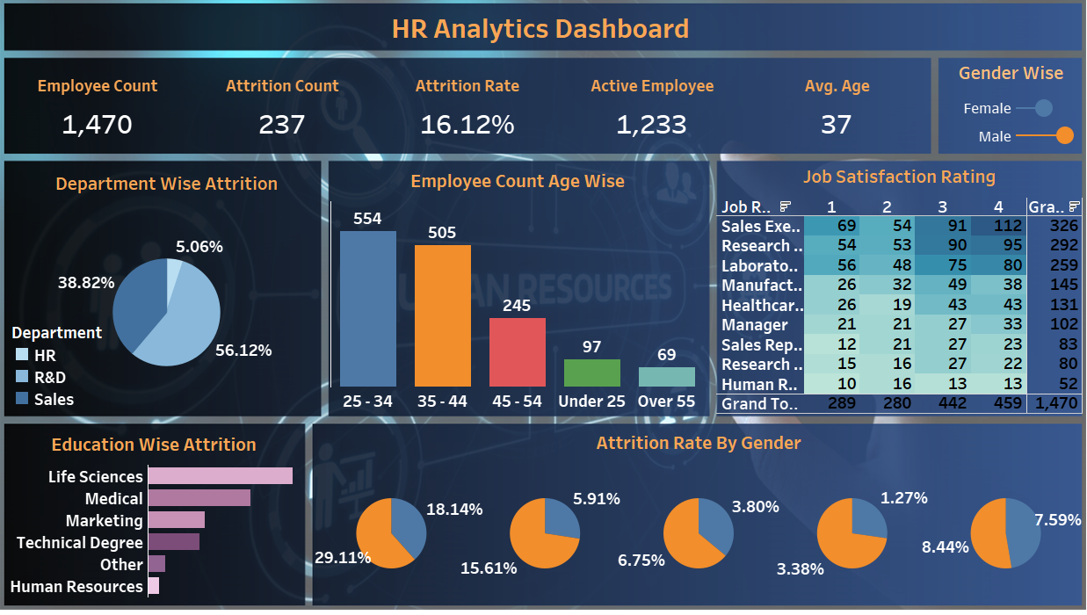

# First Worksheet (Key Performance Indicator - KPI) -

* Employee and attrition count

* We need the employee count first
* Take employee count and put this up in the text box in the marks section , (Aggregation SUM)
* Now we need the attrition count , as we can see that the attrition column is present with 'yes/no' inputs inside
* So we will create a calculated field here naming - "Attrition Count"
* Formula for attrition calculated field - IF [Attrition] = 'Yes' THEN 1 ELSE 0 END
* Now we will simply double click on the attrition and it will reflect under the (SUM(employee count)) Section in Marks area
* A new section called measure values will pop up in the marks area as well which will contain both employee count and attrition count values into
  + Consideration.
* Measure Names filter will pop up in the filter and in the column section.
* Let's put employee count before the attrition count section.
* Let's also select entire view for our worksheet.

## * Attrition Rate

* We will create another calculated field now for finding "Attrition Rate"
* The formula - SUM(Attrition Count)/SUM(Employee Count)
* Now we will simply double click on newly created "Attrition Rate " column and it will reflect under the Marks section in 'Measure Values'Box.
* The aggregation for the new column will be displayed 0 by default so we need to format the same.
* Click on format and let's go to numbers in the pane section - Percentage - 2 Decimal Places.
* Now a percentage will show in the attrition rate section.

## * Active Employee

* Create a calculated field named "Active employee"
* The formula - SUM(Employee Count) - SUM(Attrition Count)
* Now simply double click on the "Active employee column"
* Place the new column after "Attrition rate" column.

## * Average Employee Age

* We will simply double click on the age column
* By default it will display the sum of age , let's change the measure parameter and make it average.
* Now that we have all the details for the worksheet in place we will change the format.
* For all the section where data is shown without percentage we will go ahead in the format section and will create the number formatting defined as 0
* Decimal points
* Now we will be creating a global filter for all the worksheets in my dashboard
* We will use education as the filter here.
* Drag and drop education field in the filter section.
* Enable the option " Apply to all worksheets using this data source"
* From the option choose using all filters
* Use show filter option in education drop down.

# Second Worksheet (Attrition By Gender):

* SUM(atrition count) in columns and Gender in row
* We will be creating a custom lollypop chart now for the stated analysis
* For Developing the same first we will clone SUM(atrition count) in the column section again.
* Now this 2 cloned section , for one we will keep the chart type as bar and will keep the other one as a circle.
* Now we will merge both of the axis using a dual axis option.
* Now we will click on top of work sheet and use synconize axis option.
* We will now work along with sizing of the circle and bar so that it looks like a lollypop.
* Let's use Gender as colour option for both of the axis.
* Now let's use attrition count as a label for the circled axis to display the number.
* Go to the label and make the alignment a centred

# Third Worksheet (Department Wise Attrition):

* Take department column in the worksheet as in the color marks label
* Make the chart type as pie
* Now take the attrition count field and drag it into the worksheet , now the pie parts will be aligned as per department wise laid off people.
* Let's change the color pallete , use blue as our background supports the same.
* Let's put attrition count in label as well
* Let's now go to the attrition count column and from the quick table calculation section , use percentage so the percentage shows up by the side of the pie.

# Fourth Worksheet (Employee Count Age Group)

* Create a new worksheet
* Put CF age band in columns and employee count in rows
* Change colour theme as blue , do basic formating.
* This is called as a frequency chart.

# Fifth Worksheet (Job Satisfaction Rating)

* Put Job satisfaction in the columns section
* Put Job role in the row section
* Drag the job satisfaction segment in the dimensions segment
* Now take employee count and drag it onto the text section under marks label.
* Now we will use the analysis tool and will display both row and column grand total in my worksheet.
* Now after basic font and color formatting we will convert this into a heatmap from 'showme' option on worksheet right area.
* Now we will swap the roles in the worksheet from second task bar option by the side of sort options.
* We again need to perform total analysis of rows and columns (Grand totals)
* Change colours

# Sixth Worksheet (Education wise worksheet)

* Attrition count in columns
* Education field in rows
* Change colour and fonts as deemed fit.

# Seventh Worksheet (Gender Attrition - Age Group)

* CF Age band in column section
* Make the chart a pie one
* Gender dragged in colours
* Attrition Count in angle
* Formatting

# **Dash Board Creation -**

* Size - 1280*700
* Select Image from Object , Use both fit and center image
* Upload background Image
* Set object option as floating
* Drag KPI in the top second section of our background
* Colour and font formatting to be done.
* Worksheet format , shading as none so background becomes transparent.
* Set none to all row and column grid lines in pane
* We can set the number fonts directly in the worksheet as well.
* Gender wise attrition to be placed beside the kpi section box.
* We will drag the Third/Departmentwise worksheet now into the second row first column box and will adjust font an colours and everything.
* We will drag the Fourth/Age wise worksheet now into the second row second column box and will adjust font an colours and everything.
* We will drag the Fift/Job Satisfaction wise worksheet now into the second row second column box and will adjust font an colours and everything.
* We will drag the Sixth/Education wise worksheet now into the Third row first column box and will adjust font an colours and everything.
* Drag seventh worksheet and do the basics , the provide heading
* Dashboard Heading to be given.